Name: ___________________

Period: ___________________

THA #17
- Highlight sentences that explain what the author explains about curiosity. These will lead you the claim.
- Mark 5 items that surprised you and comment on them in the margins.
- Circle any words you don’t understand. Choose two to define in the margins.

When curiosity leaves a bad taste in your mouth
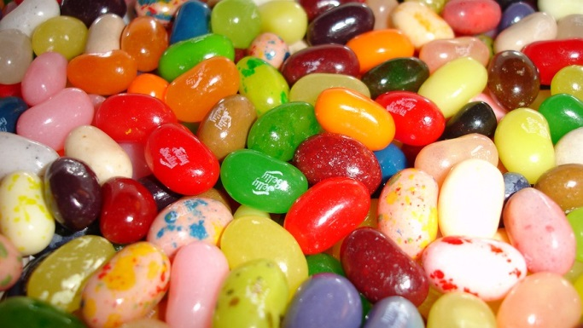
By Scientific American
The beloved Harry Potter series has enthralled readers with tales of magical potions and objects. There are invisibility cloaks, chocolate frogs, talking pictures and very unique jelly beans. These candies can be purchased by non-magical people like you and me. Bertie Bott’s Jelly Beans come in yummy flavors like blueberry, tutti-frutti and marshmallow. They also come in gross flavors like ear wax, vomit, dirt and boogers.
I was not surprised when my son wanted a box of these jelly beans, because I assumed he wanted to prank his siblings into eating a booger-flavored bean. Instead, he began tasting them himself, knowing that he was going to sample some disgusting flavors. Why would anyone subject themselves to something so unpleasant?

Curiosity Is A Powerful Motivator
New research by Christopher Hsee and Bowen Ruan suggests that the answer is curiosity. It is human nature to seek out information. Hsee and Ruan think curiosity is powerful enough to motivate us to willingly experience pain with no gain. They argue that people want to resolve uncertainty so much that they will subject themselves to unpleasant outcomes just to find answers. People want so much to know which jelly beans taste like vomit that they will actually eat them to find out.
Hsee and Ruan call this willingness to experience an unpleasant outcome to satisfy curiosity the Pandora effect. In the mythological tale, Pandora was given a box and was warned never to open it. She did so anyway, releasing all the evils of the world. History is full of cautionary tales about curiosity, like Adam and Eve, who wanted to taste the forbidden apple. Young children learn about the perils of curiosity through the mischievous stories of a monkey named George. Despite these warnings, curiosity entices humans to engage in risky behavior. People explore dangerous terrains, try illegal drugs, gamble or read text messages while driving.

Putting Their Theory To The Test
Hsee and Ruan held a series of experiments testing whether people would expose themselves to unpleasant experiences for no benefits other than to satisfy their curiosities. In their first study, participants were seated in a waiting room. While they waited for the study to begin, they were told that they could amuse themselves with novelty pens on the table. Little did the participants know, the study was already underway.
Half of the participants were in what was called a certain-outcome condition. The pens given to them had either a green dot or a red dot. The green-dot pens were regular pens, but the red-dot pens were trick pens that delivered a shock if clicked. The other half of the participants were in an uncertain-outcome condition. All of their pens had a yellow dot, and each one could be a trick pen or a regular pen. All participants were free to click, or not click, any pen on the table while they waited.
One might expect that participants would click more pens in the certain-outcome condition. To pass the time, those participants could click the green pens that were certain not to shock them. They could click the red pens that would shock them to see what it felt like. In the uncertain-outcome condition, participants risked getting shocked with every single pen click. Despite the higher risk for unpleasant results, participants clicked more pens in the uncertain-outcome condition (51 percent), than in the certain-outcome condition (30 percent).
Perhaps participants clicked the pens because they were bored. Perhaps they felt obligated to click pens for the study. However, these explanations do not account for why participants clicked more pens in the uncertain-outcome than the certain-outcome condition. Participants might have clicked more in the uncertain-outcome condition because they wanted to try both kinds of pens. Statistically, it would take more clicks to try both pen types in the uncertain condition than in the certain condition.
To control for this, Hsee and Ruan conducted a second study. In this study, all participants could click 10 pens of each color. If participants wanted to try one pen of each type, they could simply click one red and one green pen. If participants chose to click a few pens at random, they had a two-thirds chance of choosing a red- or green-dot pen. Both of these options suggest participants should have clicked more pens in the certain-outcome condition. However, they clicked 42 percent of the pens in the uncertain condition and only 14 percent of the pens in the certain condition. Clearly, participants were curious about those yellow pens.

"The Drive To Know The Unknown Is Great"
Hsee and Ruan focused only on cases in which curiosity led to unpleasant or neutral outcomes. Curiosity has historically led to positive and important discoveries, exploration and personal growth. When results are positive, entertaining or informative, it is easy to understand the value and power of curiosity. These findings show that curiosity may drive behavior even when unpleasant outcomes are expected. The drive to know the unknown is great.
My son sampled potentially disgusting jelly beans for the same reason that people slow down and gawk at car accidents. His curiosity led him to some very unpleasant outcomes. I know, because I was curious too, and my reward was the flavor of boogers in my mouth.
- What is the main claim about curiosity made by the author?

- Considering the article, what is one reason why people continue to text and drive even though they understand the dangers? (SREE)

- Do the characters in the book, Harry Potter and the Sorcerer’s Stone, do risky things because of curiosity? Explain using an example from the book. (SREE)

